A Winter Visit to the Beachmere Inn in Ogunquit, Maine

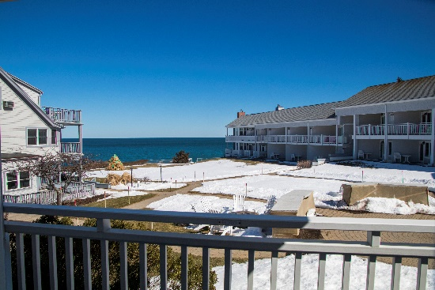As the winter season was winding down, we took a few days to relax and enjoy the winter ambience in Maine. The weather was cool or cold depending on who you asked and the skies brought sun, clouds, and finally - snow. Excellent restaurants were indeed open, the Marginal Way was cleared to walk on, and the hot tub – well…

And for the photos, click on the [Beachmere Inn -March, 2018](https://photos.app.goo.gl/miJo5uynLq9INrhZ2).